**Project Design Phase**

**Solution Architecture**

|  |  |
| --- | --- |
| Date | 16 june 2025 |
| Team ID | LTVIP2025TMID41921 |
| Project Name | Traffic Telligence :Advanced Traffic volume estimation with machine learning |
| Maximum Marks | 4 Marks |

**Solution Architecture:**

The **Solution Phase** is the stage where the actual implementation of the planned system or application takes place. Based on the design blueprint, developers and engineers build the functional product using chosen tools and technologies. For machine learning or AI projects, this phase also includes model training, evaluation, and integration.

The solution phase transforms design ideas into a real, working system. It focuses on implementing the technical solution, ensuring functionality, and preparing the product for use or delivery.

**Example - Solution Architecture Diagram:**

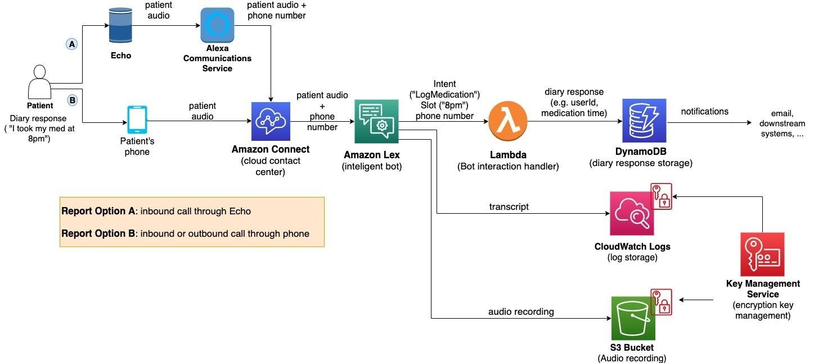

*Figure 1: Architecture and data flow of the voice patient diary sample application*